Leetcode Problem 1. (Easy)

Convert Sorted Array to Binary Search Tree

Given an integer array nums where the elements are sorted in **ascending order**, convert *it to a*

***height-balanced***

*binary search tree*.

**Example 1:**

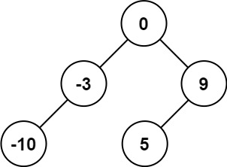

**Input:** nums = [-10,-3,0,5,9]

**Output:** [0,-3,9,-10,null,5]

**Explanation:** [0,-10,5,null,-3,null,9] is also accepted:

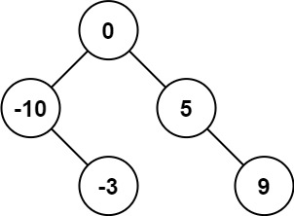

**Example 2:**

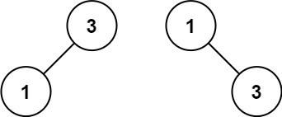

**Input:** nums = [1,3]

**Output:** [3,1]

**Explanation:** [1,null,3] and [3,1] are both height-balanced BSTs.

**Constraints:**

* 1 <= nums.length <= 104
* -104 <= nums[i] <= 104
* nums is sorted in a **strictly increasing** order.

Link: <https://leetcode.com/problems/convert-sorted-array-to-binary-search-tree/>

class Solution {

public TreeNode sortedArrayToBST(int[] nums) {

return buildTree(nums, 0, nums.length - 1);

}

private TreeNode buildTree(int[] nums, int left, int right) {

if (left > right) {

return null;

}

int mid = (left + right) / 2;

TreeNode root = new TreeNode(nums[mid]);

root.left = buildTree(nums, left, mid - 1);

root.right = buildTree(nums, mid + 1, right);

return root;

}

}

